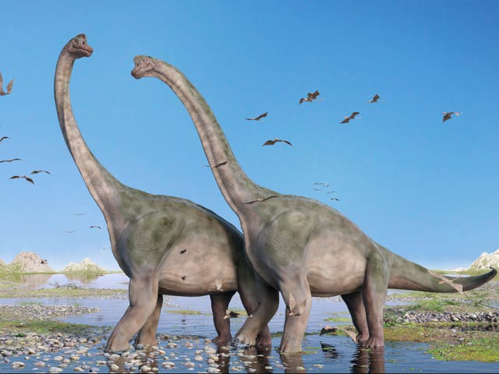

PE
EVSP dance, Thursday’s.
Dancing to Dinosaur stomp!
Games -Dinosaur Tag.
Bat and Ball Skills.
Throwing and catching games.
Running games.
Orienteering.
Mathematics
We will measure out the length and height of dinosaurs on the playground.
We will find which dinosaurs were the biggest/smallest.
We will weigh and measure our toy dinosaurs.
We will add and take away using our toy dinosaurs.
We will solve problems involving dinosaurs.
We will continue to practise recognising and ordering numbers to 20 and beyond.
We will be learning the names of both flat and solid shapes.
Communication, Language and Literacy
We will look at Dinosaur Information books.
Use information books and the internet to answer questions about Dinosaurs.
We will make our own class information book about Dinosaurs.
We will read a collection of story books and poems about dinosaurs.
We will use lots of descriptive words in our writing.
We will work hard to form our letters correctly and remember to use full stops, finger spaces and capital letters when writing sentences.
We will continue to work hard to learn our phonics, blending to read.
We will practise reading and writing the tricky words.

Discovering Dinosaurs
Summer 1 2022
Environment
Importance of looking after our world.
PSHE
Say no to bullying.
Link to appropriate dinosaur story.

Expressive Art and Design
We will work together to create our own Jurassic Forest.
Printing, splatter painting, cutting and folding.
We will enjoy painting and drawing our own dinosaurs using different media.
We will use play-dough and clay to create dinosaur models and fossils.
We will learn new dinosaur songs.
Science/Knowledge and Understanding of the World
Name, compare and sort dinosaurs.
Recognise and name parts of a dinosaur.
Piece together a dinosaur skeleton.
As historians we will dig for fossils and learn what they tell us.
We will learn about Mary Anning and
how her discovery of fossils has led us to learn all about life on our planet.

Computing
Espresso-Don’t forget to log in at home!
BBC BITESIZE- Science
Children to use iPads and Smart to research dinosaur facts.
Have a look at Oxford Owl-great for online reading books!

